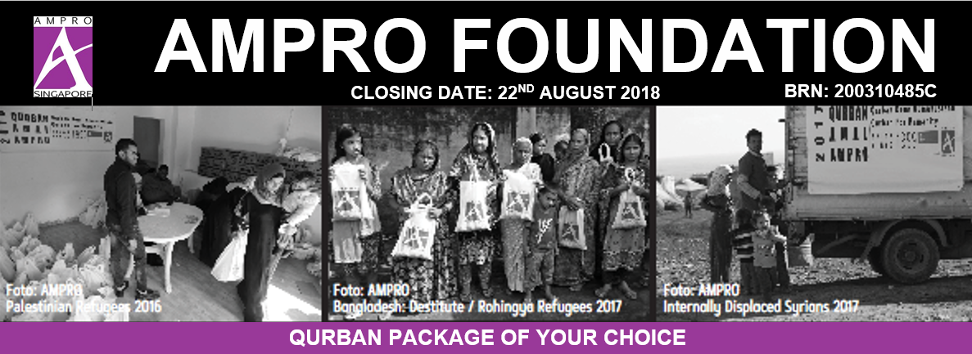
Please key in number of packages to be purchased
Qurban / Aqiqah (Sheep)
 | A | Canned (Syrian / Gaza Victims) |  |  |  |  | $250
Qurban / Aqiqah (Sheep) Local Slaughter
 | B1 | Bangladesh (Rohingya Refugees) |  |  |  |  | $220 |  | B3 |  |  | Ethiopia (Famine Victims) | $170
 | B2 | Bangladesh (Destitute) |  |  |  |  | $200 |  | B4 |  |  | Yemen (Victims of Conflict) | $330
Qurban (Cow)
 | C1 | 7 shares (Bangladesh Destitute) |  |  |  |  | $990 |  | C2 |  |  | 7 shares (Rohingya) | $1100
Humanitarian Packages
 |  | Community In Need
 | D1 | Feed The World |  |  |  |  | $100
 | D2 | Clean Water (Water Filtration Pack) |  |  |  |  | $80
 |  | Women and Children
 | E1 | Sewing course and sewing machine for Women |  |  |  |  | $400
 | E2 | Text Books & Stationery for children |  |  |  |  | $100
 | E3 | Food & Nutrition for Orphans |  |  |  |  | $50
 |  | Open Your Eyes
 | F1 | Eye Check & Treatment |  |  |  |  | $160
For information please contact: 97112824 / 84311377 / 90997344
 | I, |  |  |  |  |  |  |  | appoint AMPRO and authorize them
 | to deal with any party as they deem fit to facilitate the execution of this Qurban on my behalf;
 | and / or on behalf of:
 | NAME:
 | ADDRESS:
 | TEL:
 | EMAIL:
 | PAYMENT METHOD:
 |  |  | CHEQUE (crossed cheque payable to: AMPRO FOUNDATION LIMITED)
 |  |  | CASH (No NETS) Please make payment at our office
 |  |  | INTERBANK to account DBS Current Account 027-907384-5
 | AMPRO FOUNDATION LTD.
 | 160 Changi Road, Hexacube #02-03, (419728)
 | Email: ampro.foundation@gmail.com
 | Facebook: http://www.facebook.com/ampro.foundation
 | Website: http://www.amprofoundation.com

